Keypoint Task Bug Report Documents

**Bug ID** : #1111

**Bug Name** :Login - Fail login attempt with a valid credential

**Summary** : When I enter valid credentials and password, one username out of four valid usernames couldn’t log in website.

**Submit Date** : 21.04.2020

**Reporter** : Sinan Yilmaz - Quality Assurance Engineer | Green Team

**Platform** : MacOS

**Operation System** : OS X 11.6.5

**Browser** : Chrome 100.0.4896.127

**URL** : <https://www.saucedemo.com>

**Step Procedure** : Go to URL <https://www.saucedemo.com>

Enter username as given ‘locked_out_user’

Enter password as given ‘secret_sauce’

Click on ‘Login’ button

**Expected Result** : The user ‘locked_out_user’ should land on home page.

**Actual Result** : The user got error message and couldn’t land on page

**Screenshot** :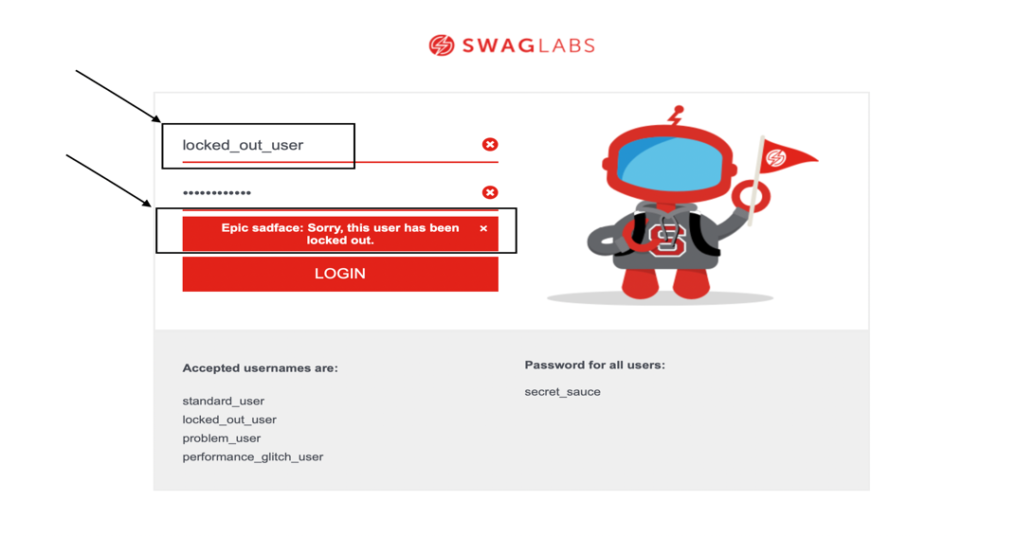

**Bug ID** : #2222

**Bug Name** :HOME PAGE – All product picture are somewhat a dog picture

**Summary** : After login with ‘problem_user’ username and ‘secret_sauce’ password, Facing with mismatch picture with product name.

**Submit Date** : 21.04.2020

**Reporter** : Sinan Yilmaz - Quality Assurance Engineer | Green Team

**Platform** : MacOS

**Operation System** : OS X 11.6.5

**Browser** : Chrome 100.0.4896.127

**URL** : <https://www.saucedemo.com>

**Step Procedure** : Go to URL <https://www.saucedemo.com>

Enter username as given ‘problem_user’

Enter password as given ‘secret_sauce’

Click on ‘Login’ button

**Expected Result** : All product’s picture should be related with product name

**Actual Result** : All product’s picture are unrelated a dog picture.

**Screenshot** :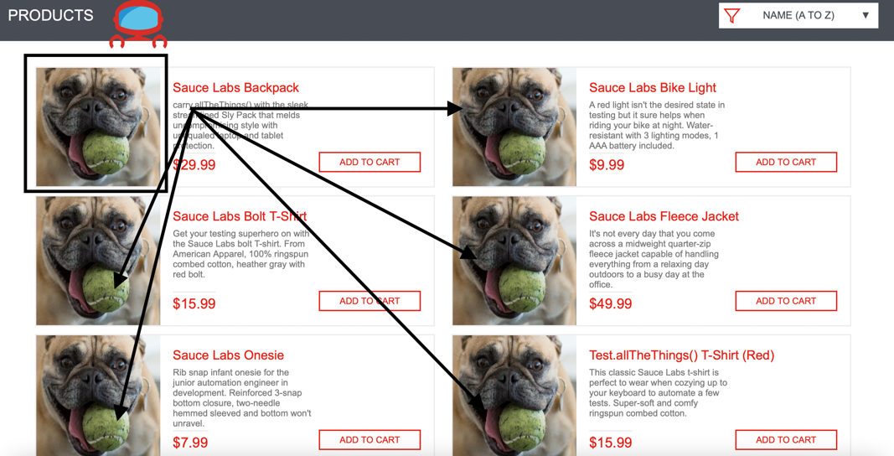

**Bug ID** : #3333

**Bug Name** :PRODUCT PAGE - URL mismatch issue at product page

**Summary** : After login with ‘problem_user’ and clicking on random product, the product URL clicked on at home page doesn’t match with related product URL.

**Submit Date** : 21.04.2020

**Reporter** : Sinan Yilmaz - Quality Assurance Engineer | Green Team

**Platform** : MacOS

**Operation System** : OS X 11.6.5

**Browser** : Chrome 100.0.4896.127

**URL** : <https://www.saucedemo.com>

**Step Procedure** : Go to URL <https://www.saucedemo.com>

Enter username as given ‘problem_user’

Enter password as given ‘secret_sauce’

Click on ‘Login’ button

Click on any product name

**Expected Result** : After clicking product at home page, the user should see same product clicked before

**Actual Result** : The user see different product page even though clicked on different product

**Screenshot** :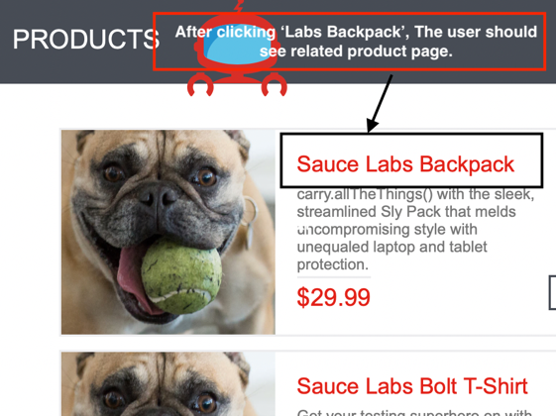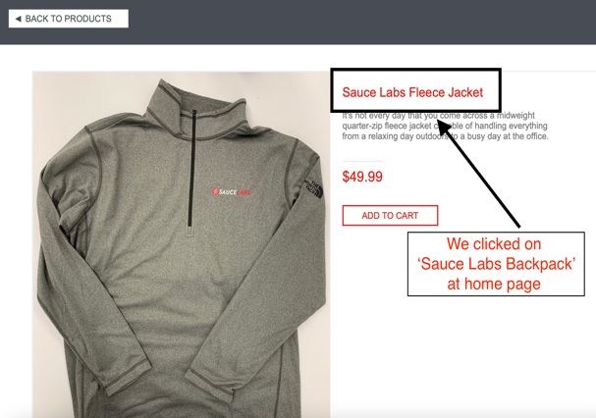

**Bug ID** : #4444

**Bug Name** :CART – Able to checkout without add nay product

**Summary** : Without adding any product to the cart, the user is able to checkout and gives order without

any restrictions

**Submit Date** : 21.04.2020

**Reporter** : Sinan Yilmaz - Quality Assurance Engineer | Green Team

**Platform** : MacOS

**Operation System** : OS X 11.6.5

**Browser** : Chrome 100.0.4896.127

**URL** : <https://www.saucedemo.com>

**Step Procedure** : Go to URL <https://www.saucedemo.com>

Enter username as given ‘problem_user’

Enter password as given ‘secret_sauce’

Click on ‘Login’ button

Go to CART by clicking cart icon placed on right top of the website.

Pursue the procedure to finish order.

**Expected Result** : The website should create some restriction if anybody try to checkout without adding product

**Actual Result** : The user is able to checkout without facing any restrictions and gives order

**Screenshot** : 